UNIVERSITY OF ENGINEERING AND TECHNOLOGY

(NAROWAL CAMPUS)



# Object-Oriented Programming Lab Manual

Created by: Muhammad Abdullah

Registration Number: 2022-CS-525

Topics: Passing Structure as a parameter to function

by value and by reference, Create an array of Structure,

nested Structure, Pointer of Structure, Vector Container Functions

Lab Manual

(Object-Oriented Programming Lab)

* **Task 1-A:**

Pass s structure to a function as a parameter by value in a C++ program

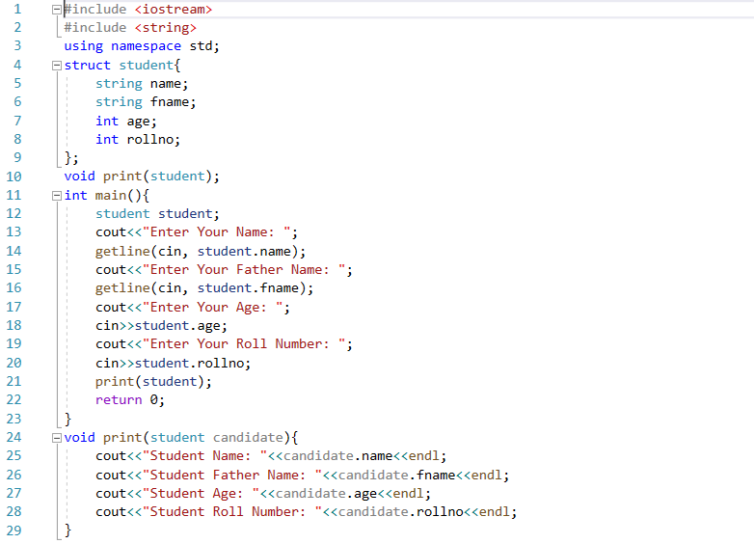Program:

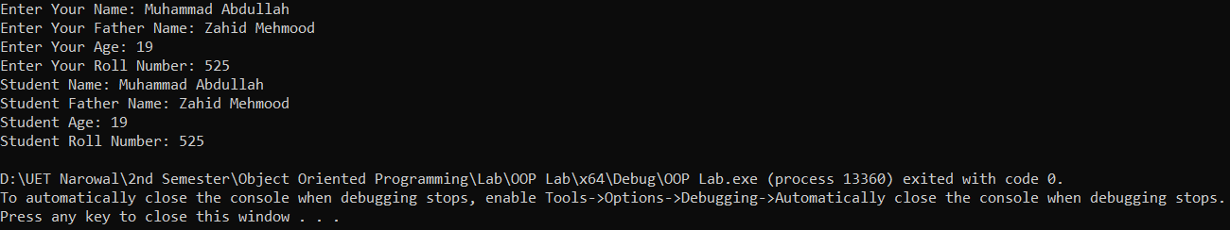Output:

* **Task 1-B:**

Pass s structure to a function as a parameter by reference in a C++ program

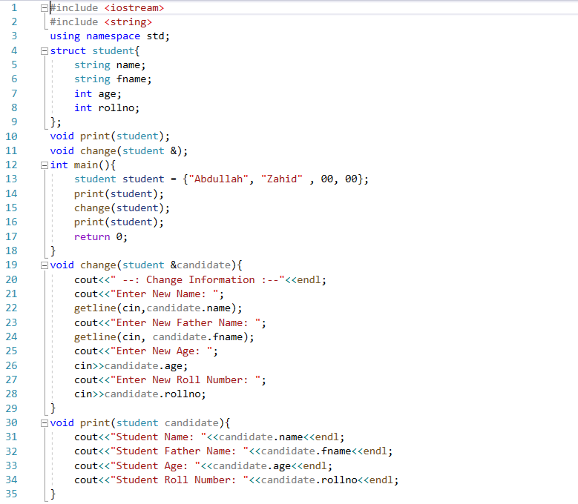Program:

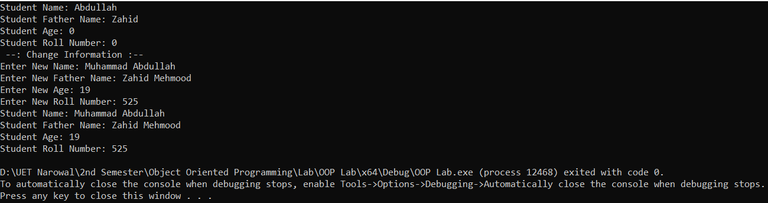Output:

* **Task 2:**

Create an array of structures in a C++ program

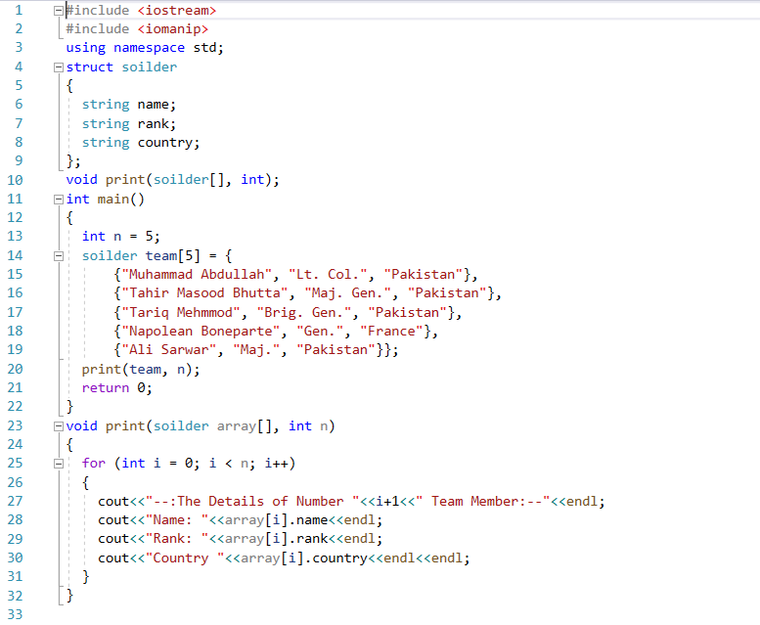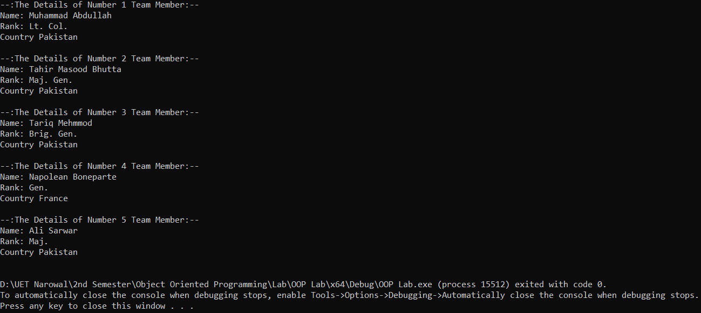Program:

Output:

* **Task 3:**

Create a structure that contains another structure variable as its member in the C++ program

Program:

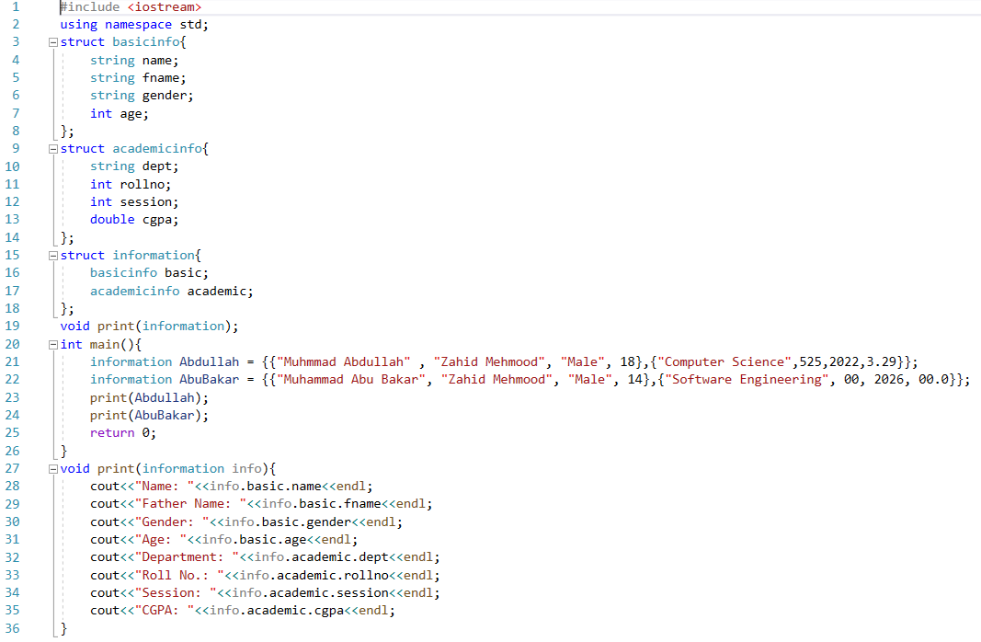

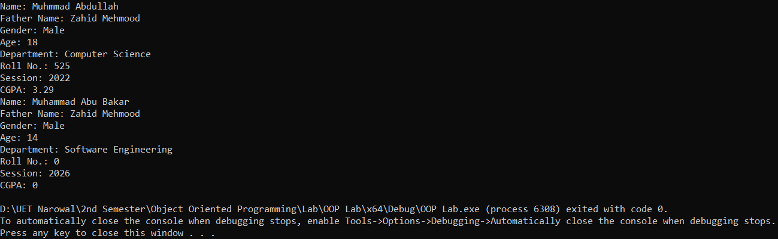Output:

* **Task 4:**

Create a pointer variable that points to a structure variable in a C++ program

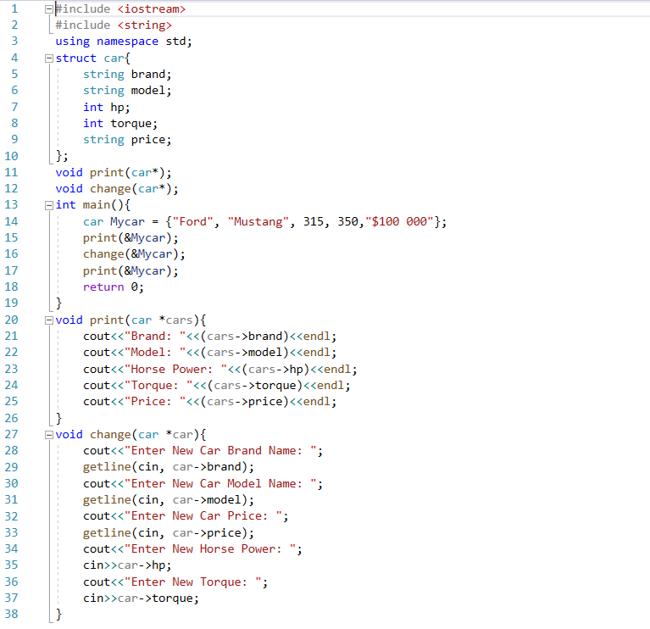Program:

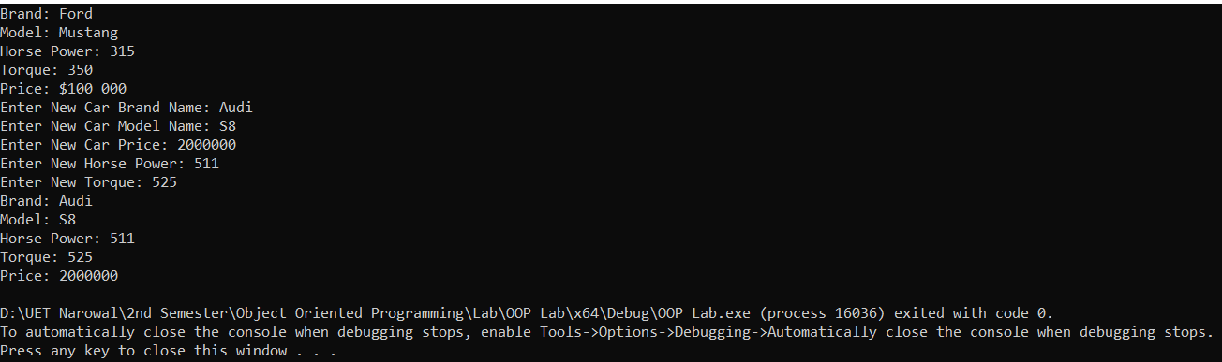Output:

* **Task 5:**

Create a vector container and apply some pre-defined functions of the vector header file on it in a C++ program

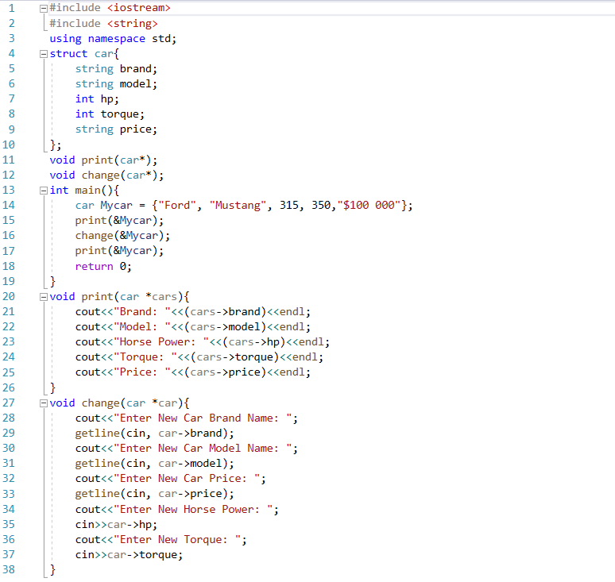Program:

Output:



